**RAJALAKSHMI ENGINEERING COLLEGE**

**RAJALAKSHMI NAGAR, THANDALAM – 602 105**



|  |
| --- |
| **CS23A34**  **USER INTERFACE AND DESIGN LAB** |
| **Laboratory Observation NoteBook** |

**Name :** Savita Shri G

**Year/Branch/Section :** II/CSE/F

**Register No. :** 230701299

**Semester :** IV

**Academic Year:** 2024-25

**Ex. No. : 6b Date : 29.03.2025**

**Register No. : 230701299 Name : Savita Shri G**

**Simulate the life cycle stages for UI design using the RAD model and develop a small interactive interface**

**using OpenProj**

**AIM:**

The aim is to recreate the lifecycle stages of UI design using the

RAD model and design a small interactive interface with

OpenProj

**PROCEDURE:**

Tool Link: https://sourceforge.net/projects/openproj/ **Step 1: Requirements Planning**

1. Gather Requirements:
   1. Identify key features and functionalities needed for your interface.

○ Example: A simple "Login" and "Register" interface with debug logs.

1. Define Use Cases:
   1. Specify use cases for user login and registration. ○ Example: User logs in with valid credentials, user registers with a new account.

Output in OpenProj:

* Create a new project.
* Add tasks: "Gather Requirements" and "Define Use

Cases." ● Set durations and dependencies for each task.

**Step 2: User Design**

1. Sketch Initial Designs:
   1. Draw rough sketches of the "Login" and "Register" screens on paper.
2. Create Digital Wireframes:
   1. Use a tool like Figma or Sketch to create digital wireframes.

Example Wireframes:

1. Login Screen: Username field, Password field, Login button, Register link.
2. Register Screen: Username field, Email field, Password field, Confirm Password field, Register button.

Output in OpenProj:

* Add tasks: "Sketch Initial Designs" and "Create Digital

Wireframes."

* Allocate time and resources to complete these tasks. **Step 3: Rapid Prototyping**

1. Develop Prototypes:
   1. Use a tool like Axure RP to convert wireframes into interactive prototypes.
2. Test Prototypes:
   1. Share prototypes with stakeholders for feedback. ○ Collect feedback and iterate on the design.

Output:

* Interactive prototypes for "Login" and "Register" screens. Output in OpenProj:
* Add tasks: "Develop Prototypes" and "Test

Prototypes." ● Set dependencies and milestones.

**Step 4: User Acceptance/Testing**

1. Review Prototype:
   1. Conduct user and stakeholder reviews.
2. Conduct Usability Testing:
   1. Perform usability testing and document feedback. Output:

* Documented feedback and test results.

Output in OpenProj:

* Add tasks: "Review Prototype" and "Usability

Testing." ● Track progress and resources.

**Step 5: Implementation**

1. Develop Functional Interface:
   1. Implement final designs and functionalities based on feedback.
2. Integrate Backend (if required):
   1. Connect the UI with backend services for tasks like user authentication.

**OUTPUT:**

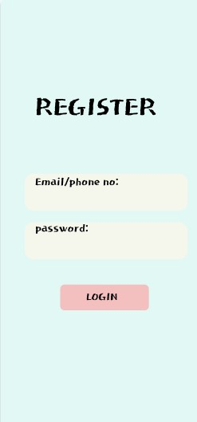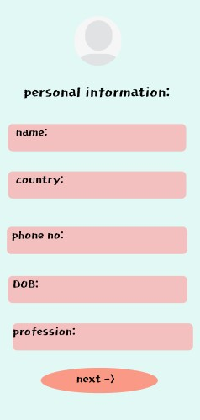

**RESULT:**

Hence the lifecycle stages of UI design using the RAD model and design of a small interactive interface with OpenProj has been successfully executed.